**CS6240, HW 1, Rushil Patel**

**Exploration Challenge**

In Hadoop Distributed File System there is no provision for performing update operations on the File once written.

MapReduce works on the principle of write once and read many times.

The following is the evidence that HDFS does not support for updates to a file once written

Source : Hadoop the Definitive Guide Book

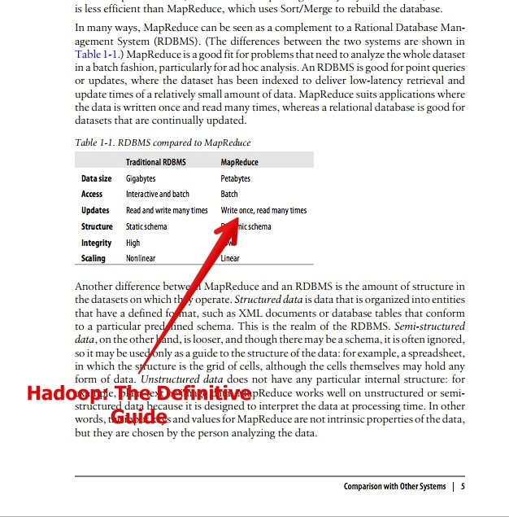

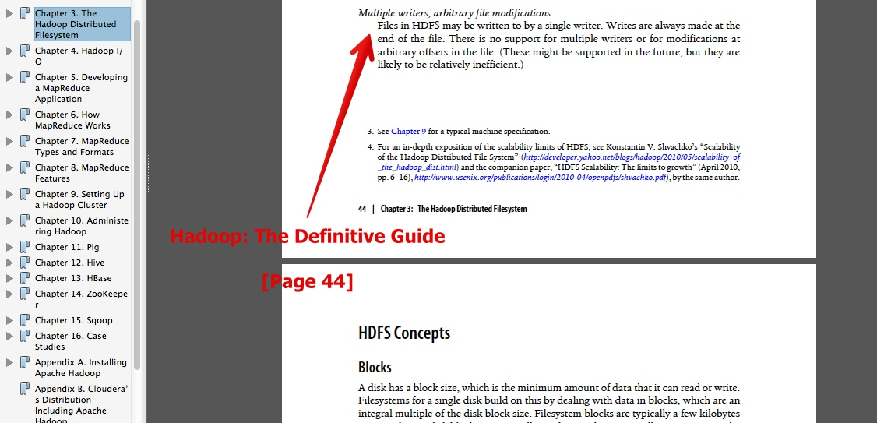

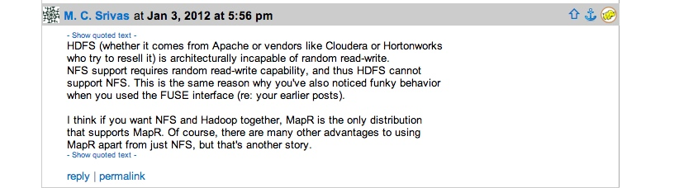

Figure http://grokbase.com/t/hadoop/hdfs-user/1213gt4fvz/file-edit-in-hadoop

**Local Execution**

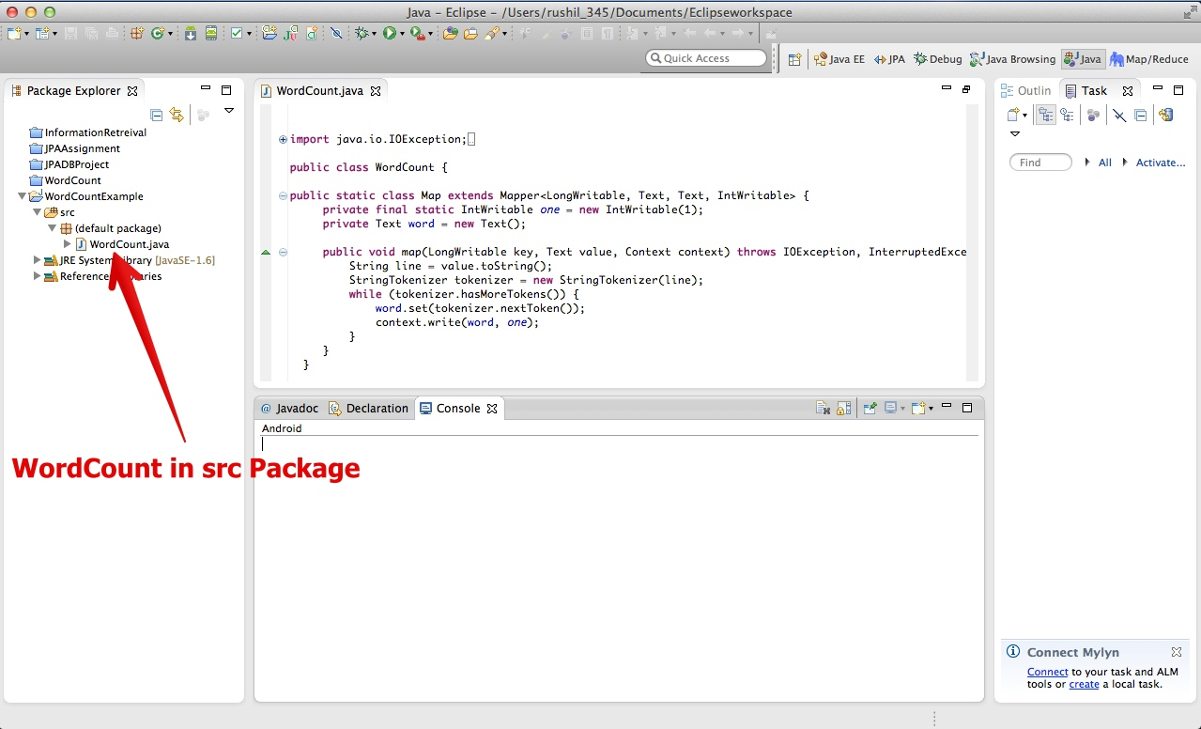

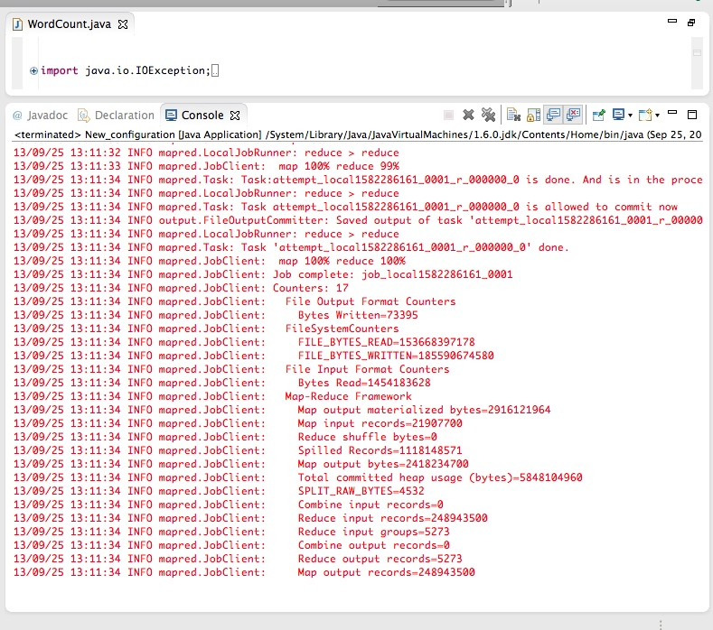

**AWS Execution**

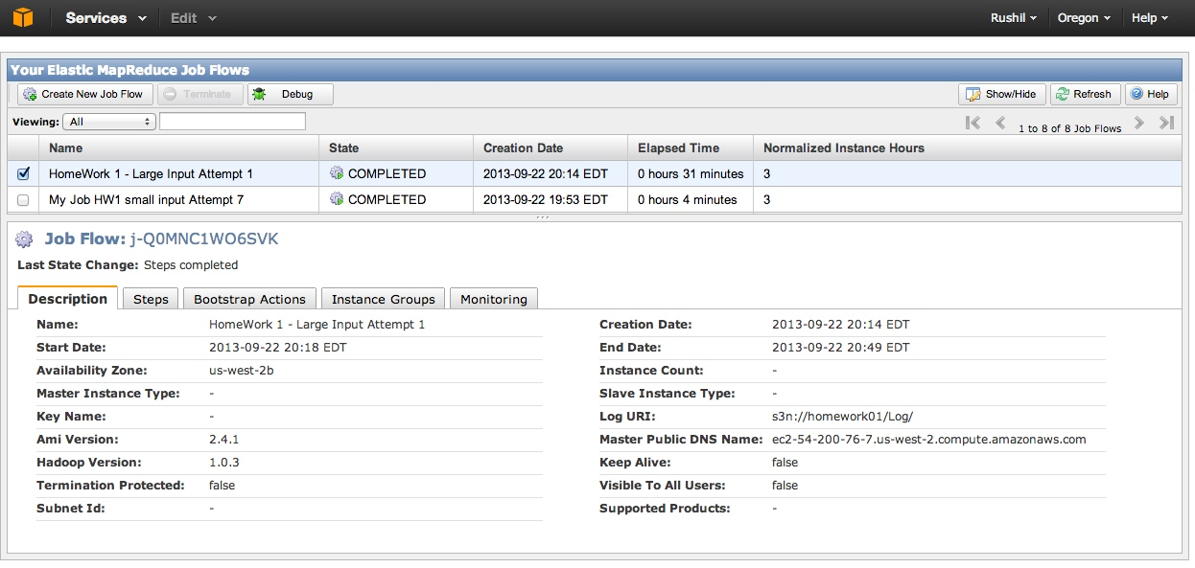

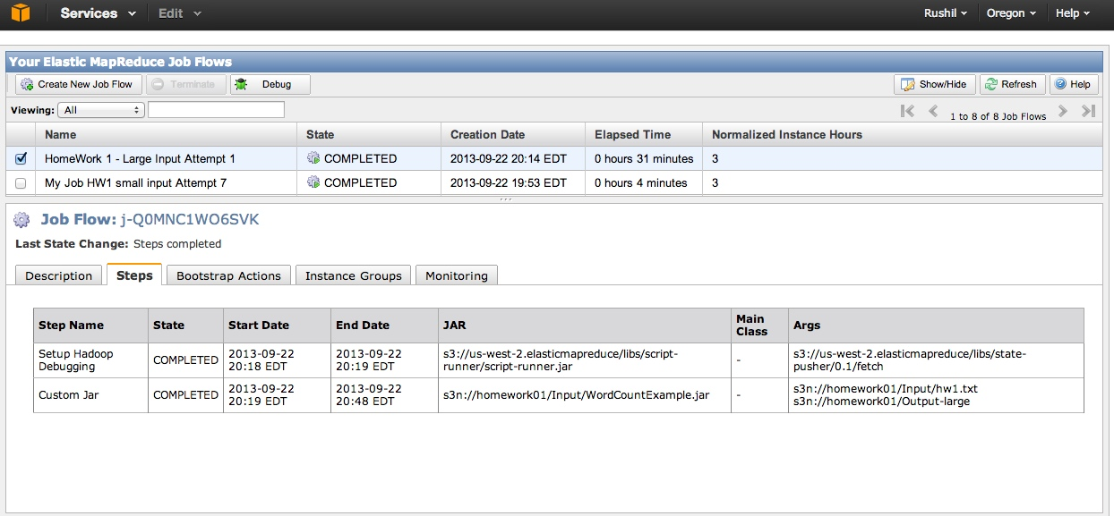

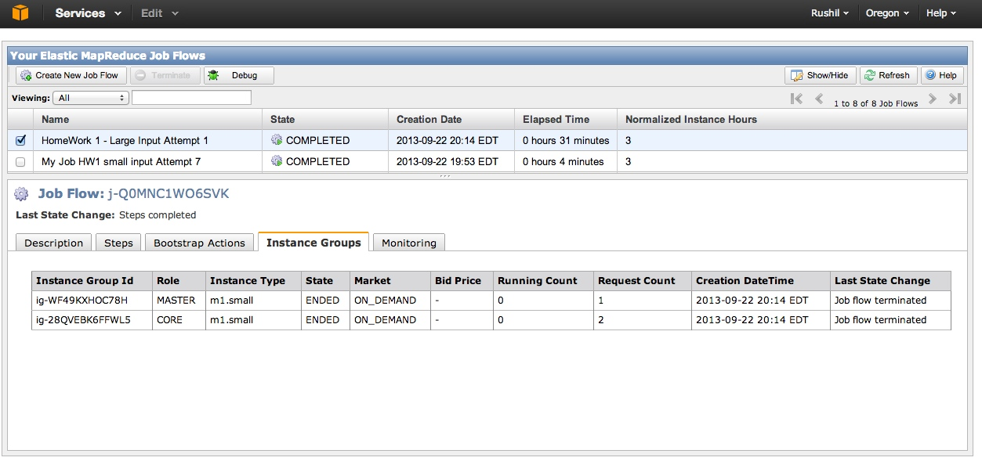

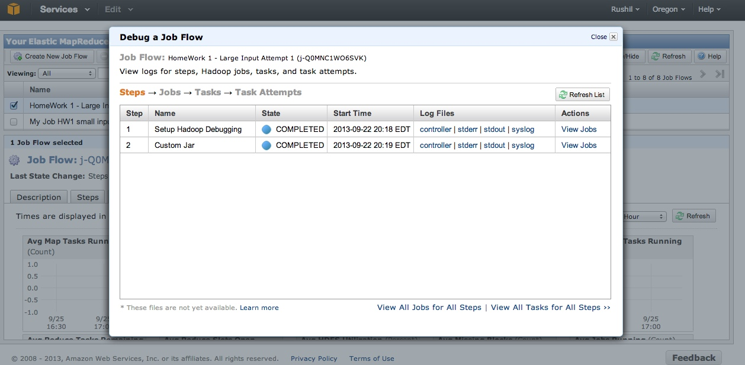

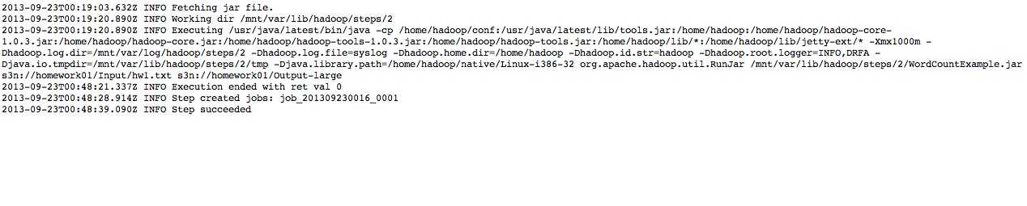

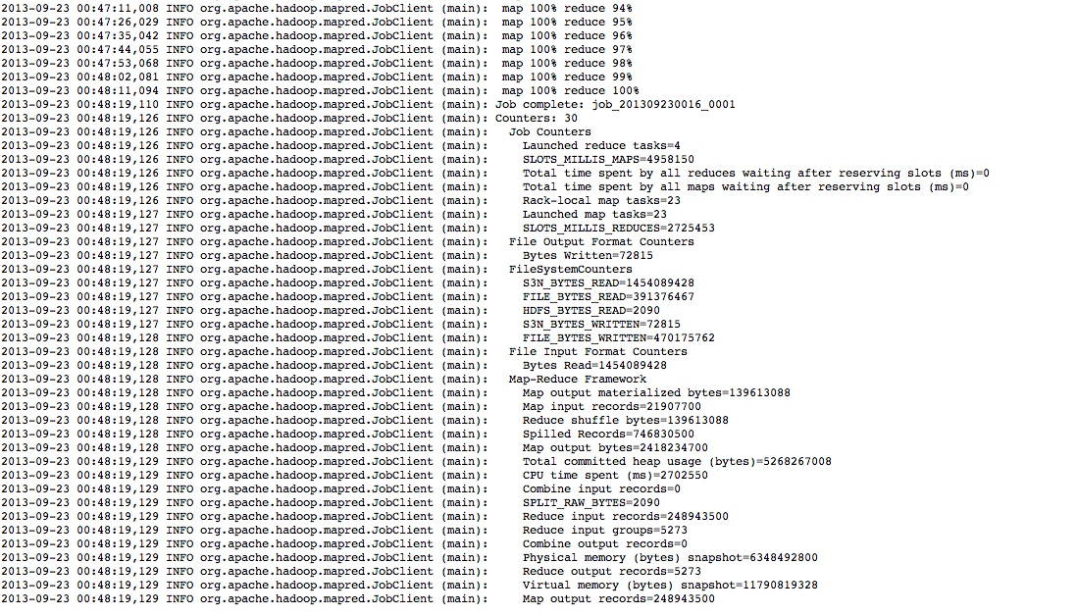

**Note:**

**All the above files are available in the Images folder of this supplied Zip file.**

**Credits: Hadoop Library for WordCount Example & AWS.**